English
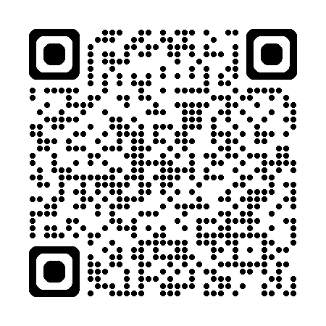
Diagnostic Test: Third Secondary (Grade 12), First Term 2026

